**Attrition Project**

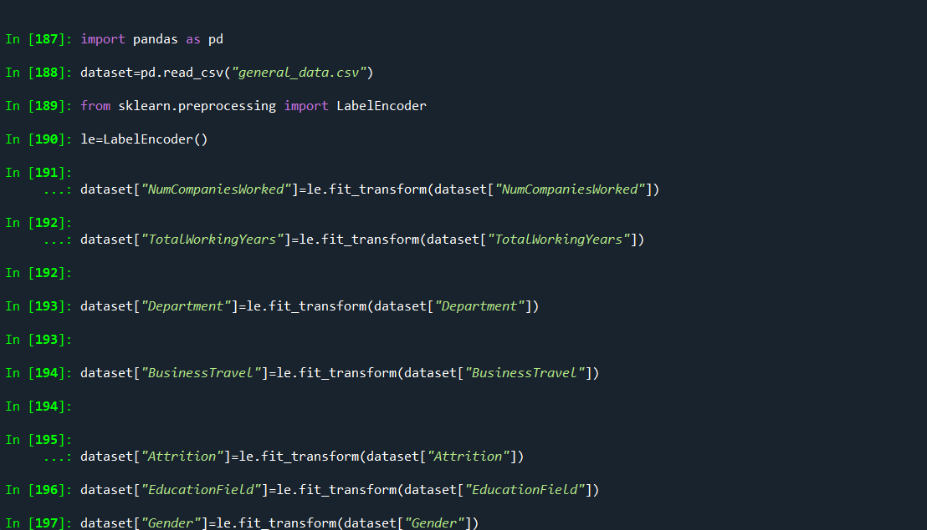

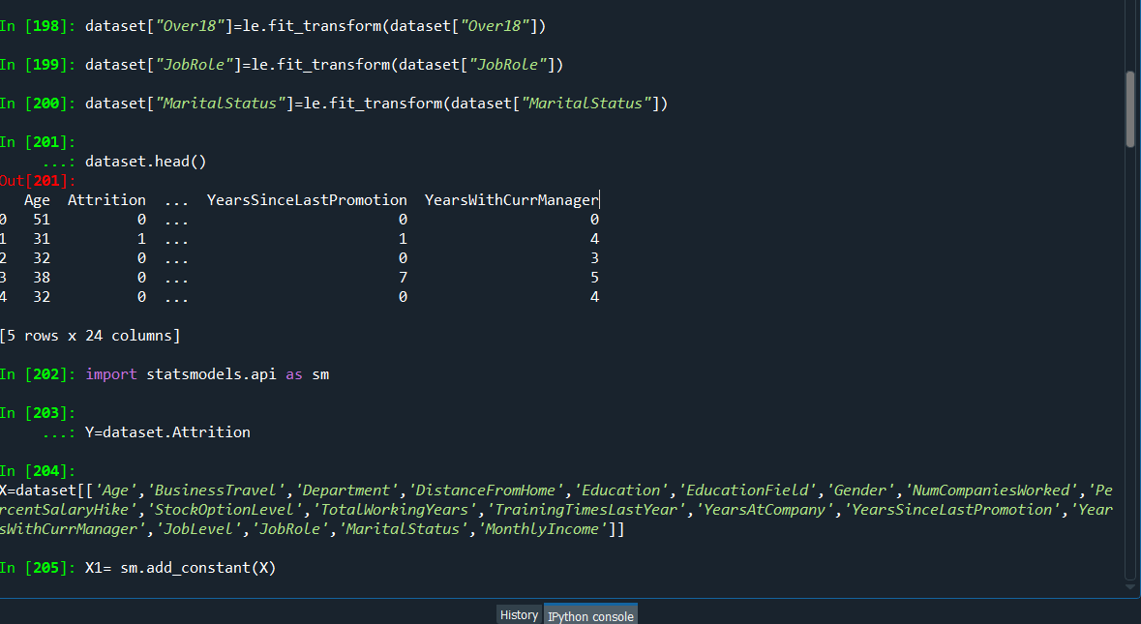

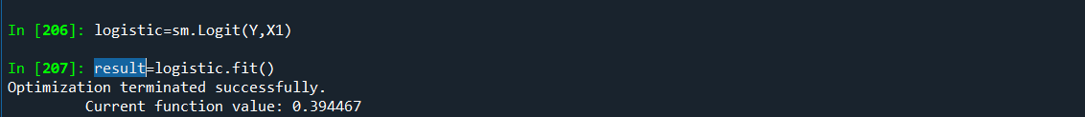

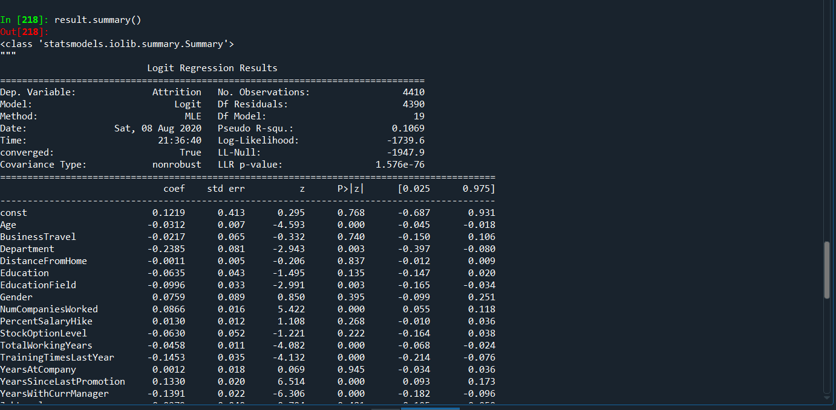

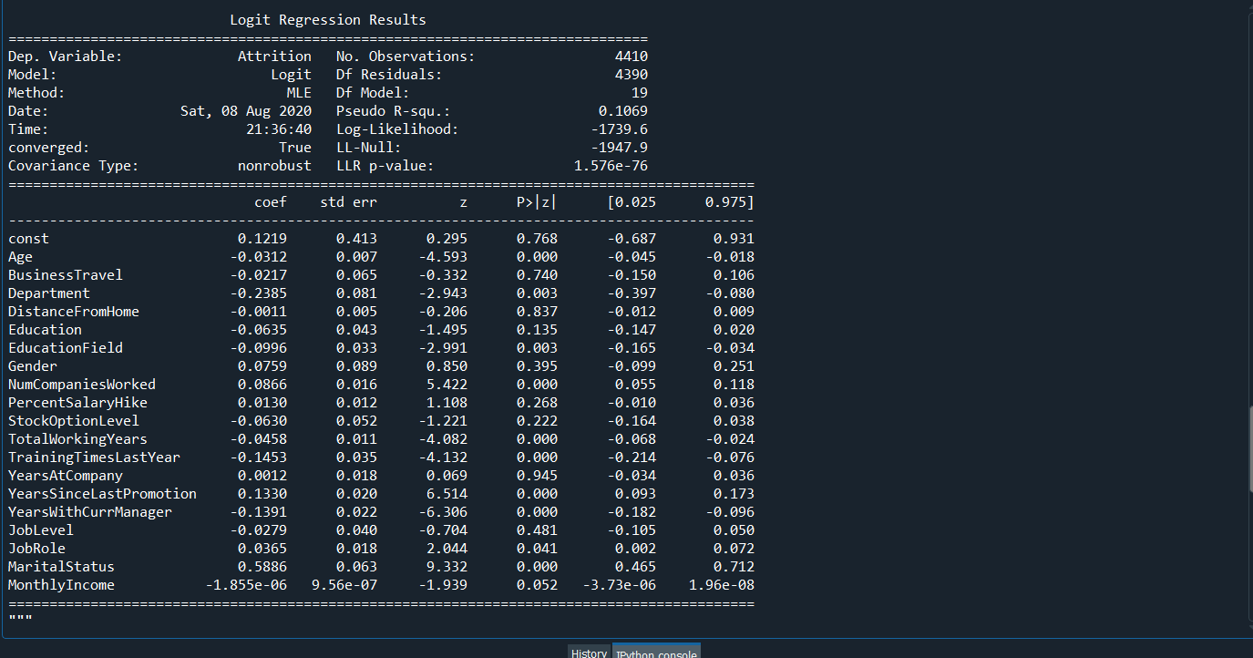

**Inference:**

**1.The more significant Variables are:**

**Age,MaritalStatus,NumCompaniesWorked,TotalWorkingYears,TrainingTimesLastYear ,YearsSinceLastPromotion ,YearsWithCurrManager**

**2.The less significant Variables are:**

**Gender, Department, EducationField, JobRole, Monthly, income, Stock option level, Job level ,Percentage salary hike**

**3.Not significant Variables are:**

**Business Travel ,Distance From Home ,years at company**